Name: Jay Rajesh Umap

Roll No.: 2205010

Enrolment No.: MITU20BTIT0029

Class: LY IT Core

Lab Assignment No. 5:

Find a procedure to transfer file from one Virtual Machine to another Virtual Machine.

Steps:

1. 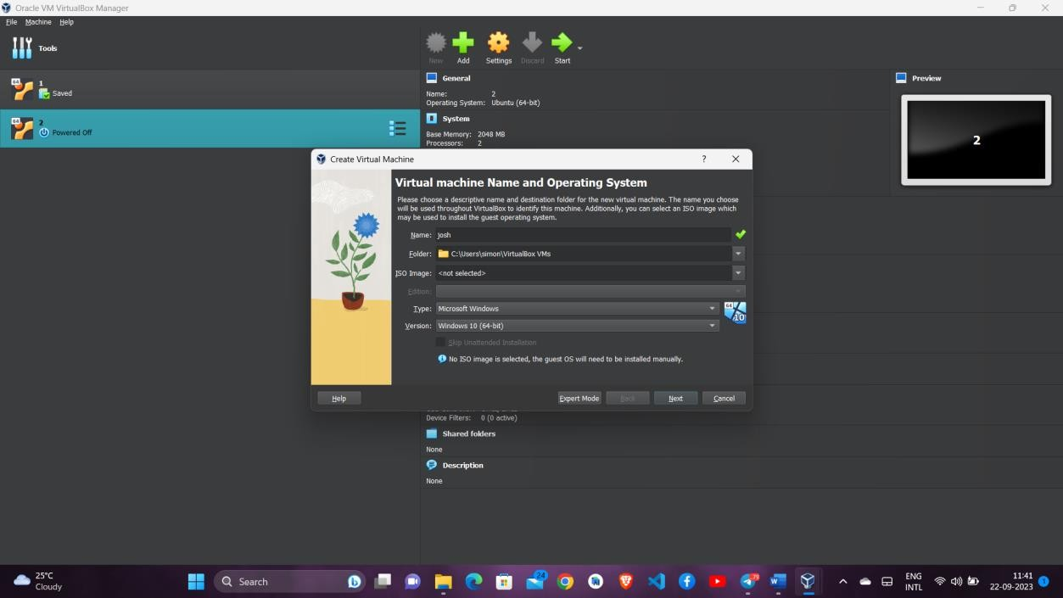Create an instance in the virtual box.
2. 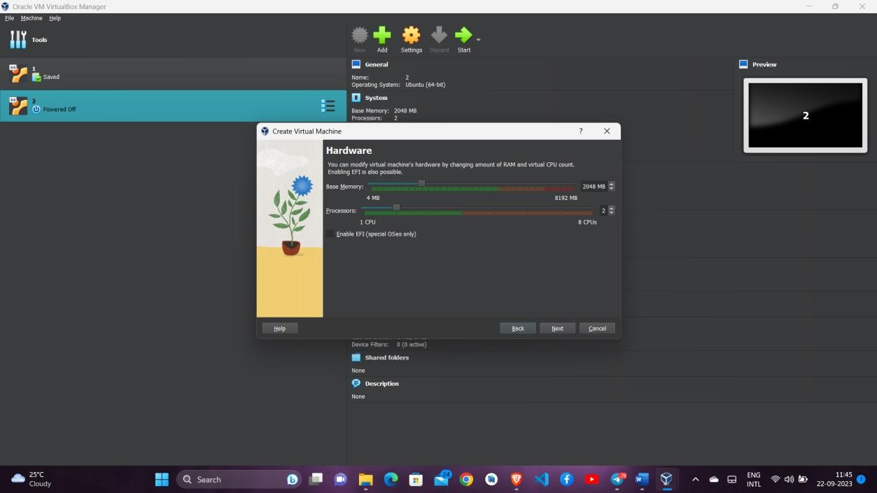Setup Base Memory and Processors according to your requirement.
3. Download ubuntu vmdk file from link: <https://drive.google.com/file/d/1Brdmpy2yP1QC8R47OhVXYnBtYPJ7MGsN/view?usp=sharing>
4. 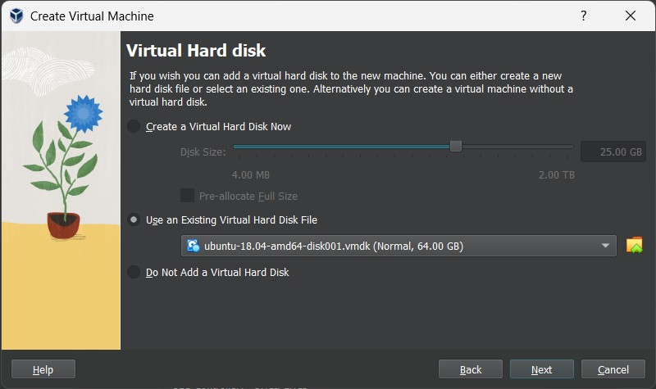Add it in “use a virtual hard disk file” section while setting up instance
5. Now you have successfully created the instance
6. Now go to settings and choose storage options

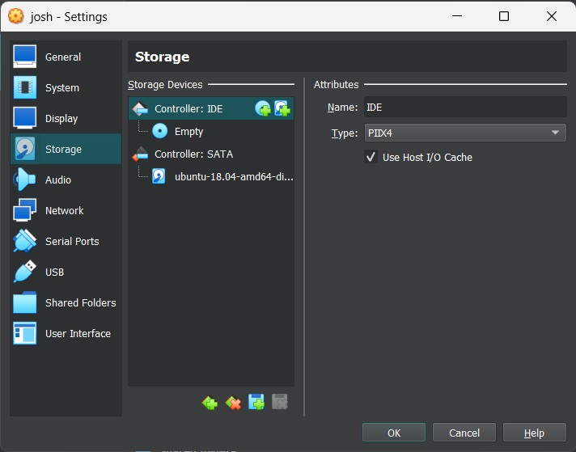

1. Choose the controller SATA and add Ubuntu file here. Go to network settings and add change network to NAT network

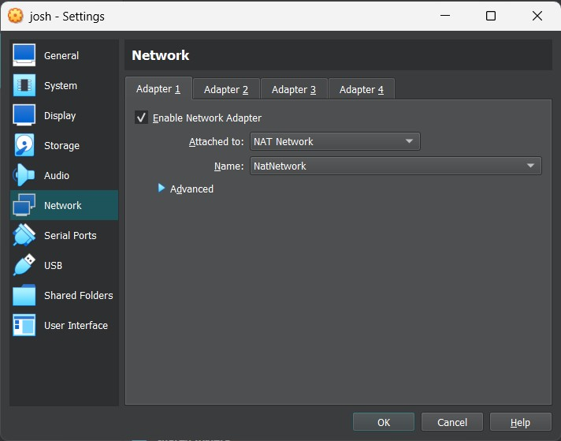

1. Repeat all the above steps to create one more instance.
2. Start both the Virtual Machine login to the vagrant on both the machine.

Login: vagrant

Password: vagrant

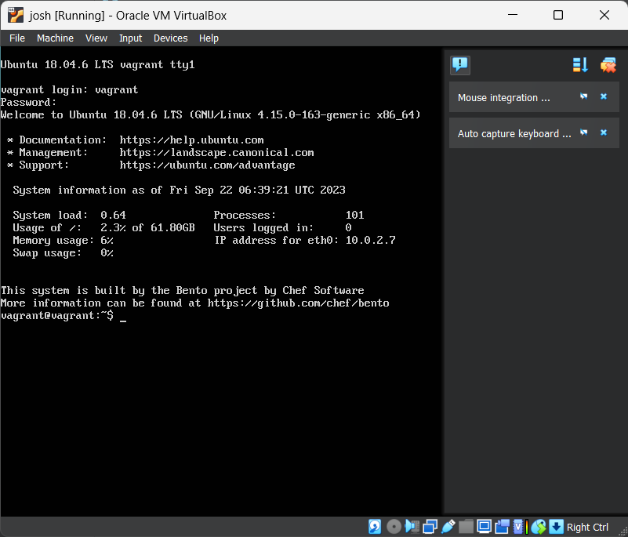

1. Install the net-tools to know the IP's of the instance.

# $sudo apt install net tools

$ifconfig

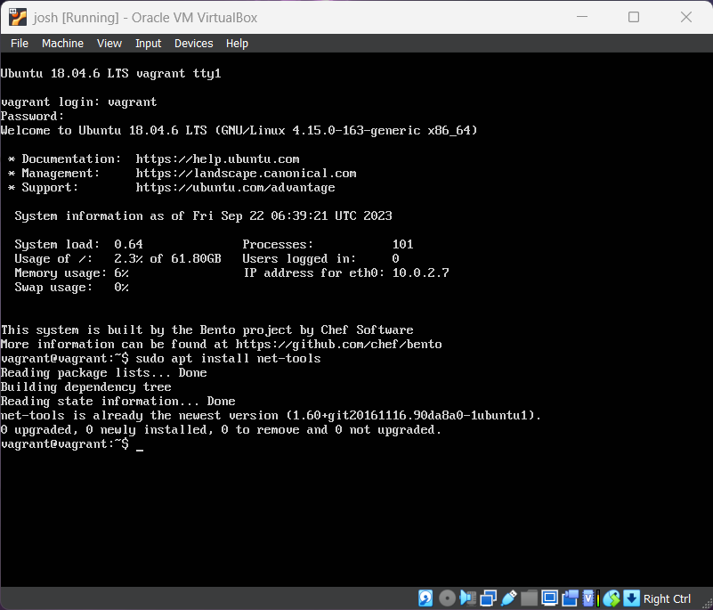

1. Now create a file and write something into it.

# $ touch transfer.txt

$ nano transfer.txt

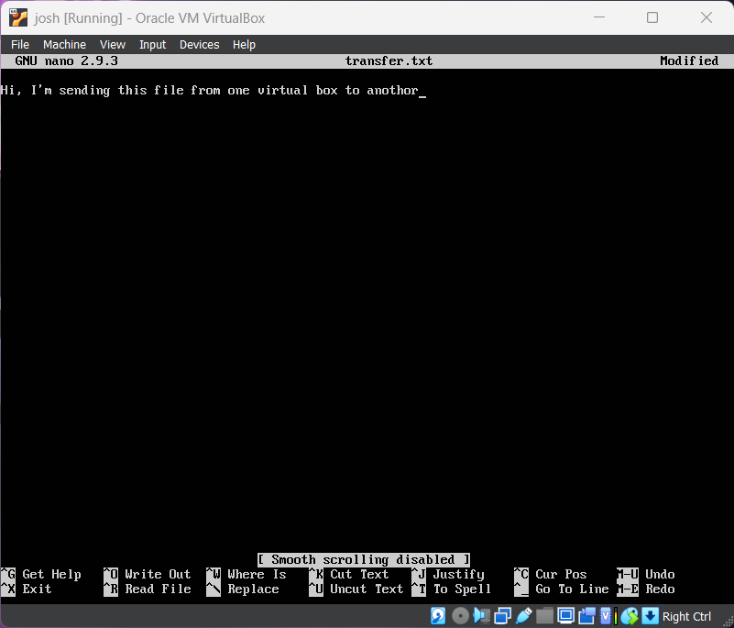

1. Transfer file using command: scp transfer.txt [vagrant@10.0.2.8](mailto:vagrant@10.0.2.8) :/home/vagrant

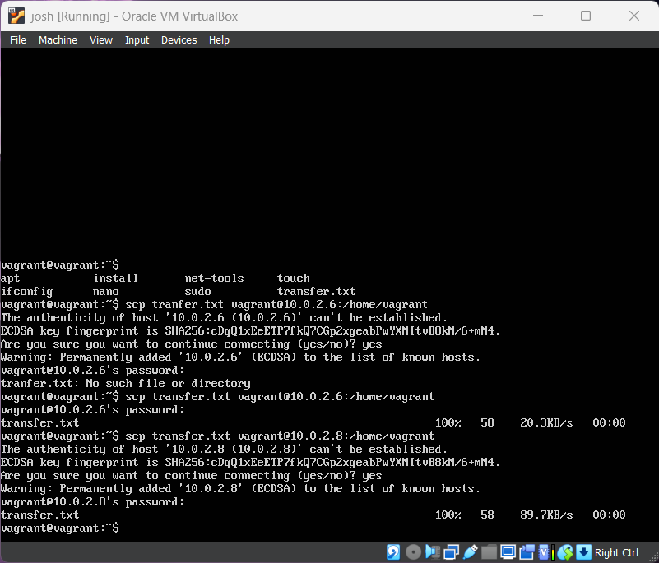

1. Put the password of 2nd VM and done file is transferred. Check for file in 2nd VM /home/vagrant directory

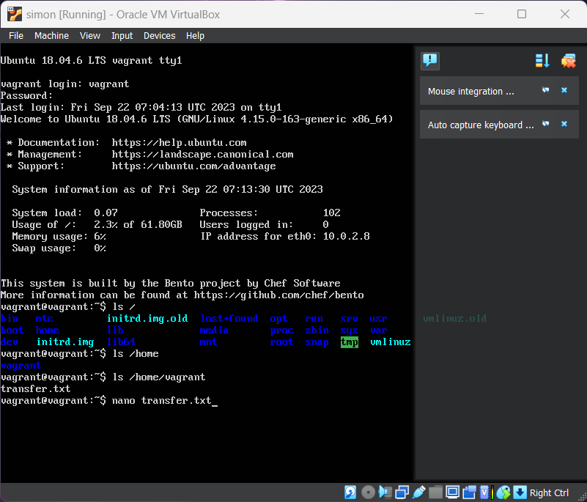

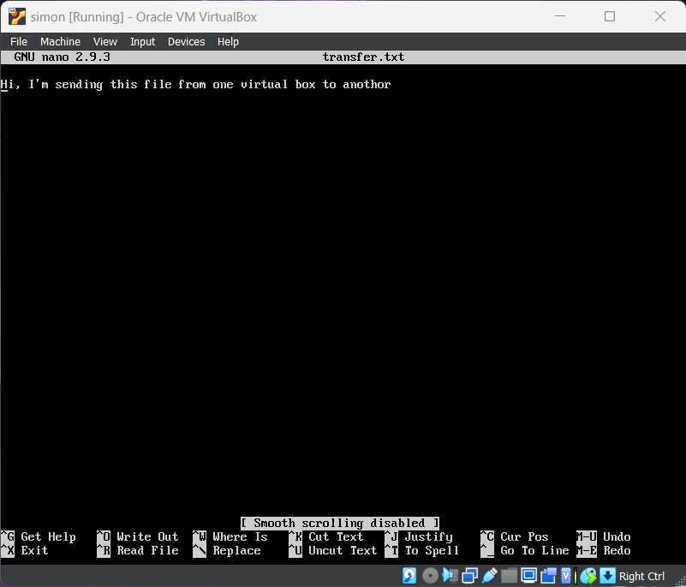

Conclusion: In this assignment we have successfully learned how to transfer one file from one virtual machine to another.